[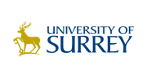](http://www.surrey.ac.uk/)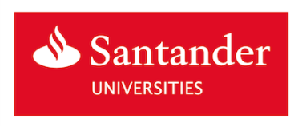

**Doctoral College Conference**

**Invitation to International PhD Students to Apply for Funded Places**

The University of Surrey is inviting PhD/Doctoral students from selected universities that are part of the Santander Universities network to apply to attend the University’s Doctoral College Conference. The Conference will take place on 3rd and 4th July at the University of Surrey, Guildford, UK.

The Conference theme is **Breaking New Ground.** The event will showcase the many ways in which PhD students and Early Career Researchers are breaking new ground with their research. This could be by challenging a previous research paradigm, trialling a new methodology, or exploring a new subject area. The conference will also consider the potential for ground breaking interdisciplinary and multidisciplinary approaches.

With the generous support of Santander Universities up to 15 places are available for international PhD students to attend the Conference and present a poster or deliver an oral presentation.

Travel and accommodation (expected to be in university residences) expenses will be covered for each recipient. Accommodation will be provided from 30th June to 5th July to allow participants time to explore the potential for establishing academic connections with students and staff at the University of Surrey. Participants will be responsible for all other expenses including food and insurance, and for making their own visa arrangements (where applicable).

To apply you will need to submit an abstract (in English, maximum 250 words) describing what you would like to present (either as an oral presentation or a poster) and how this will address the Conference theme ‘Breaking New Ground’. You will also be asked to provide the following information:

* The university where you are pursuing your PhD
* Your PhD topic
* Abstract title

***All applications should be submitted via the online tool:*** <https://surrey.onlinesurveys.ac.uk/doctoral-college-conference-2018-international-2>

***The deadline for applying is: 16th March 2018***

You will be advised of the outcome of your application by the end of April 2018.